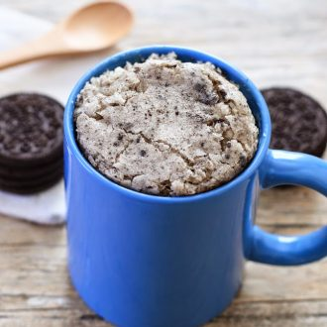
COOKIES AND CREAM MUG CAKE
PRINT RECIPE

INGREDIENTS:
- 1/4 cup white chocolate chips
- 3 tbsp whole milk
- 4 tbsp all-purpose flour
- 1/4 tsp baking powder
- 1/2 tbsp vegetable oil
- 2 Oreo cookies

DIRECTIONS:
- Combine white chocolate chips and milk in an oversized microwave-safe mug. Microwave for about 40 seconds. Mix with a small whisk until chocolate is completely melted.
- Add flour, baking powder, and oil and whisk until batter is smooth.
- Using a fork, smash Oreos into the batter until only small chunks of cookie remain.
- Cook in microwave for about 1 minute. Let cake cool a few minutes before eating. Cake is best consumed while still warm.

